**THE SIESTA BEACH**

**Siesta Beach** (sometimes known as **Siesta Key Beach**) is a [beach](https://en.wikipedia.org/wiki/Beach) located on [Siesta Key](https://en.wikipedia.org/wiki/Siesta_Key) in the U.S. state of [Florida](https://en.wikipedia.org/wiki/Florida). The southern portion of Siesta Beach is alternatively called Crescent Beach, which extends to the [seawall](https://en.wikipedia.org/wiki/Seawall) and Point of Rocks, an area with coral and active marine life.

Siesta Beach is not only long, but also expansively wide, especially around the Siesta Key Beach Pavilion section. The beach is so wide the city installed walking mats to help beachgoers get to the shore, where they can then walk on firmer wet sand.

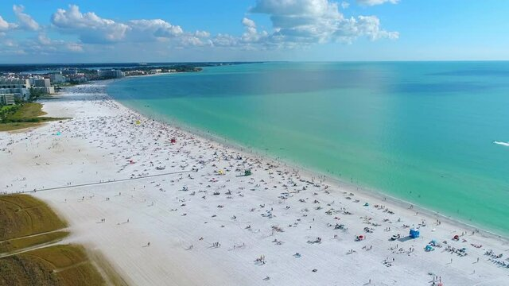

Unlike beaches elsewhere that are made up mostly of pulverized [coral](https://en.wikipedia.org/wiki/Coral), Siesta Beach's sand is 99% quartz, most of which comes from the [Appalachian Mountains](https://en.wikipedia.org/wiki/Appalachian_Mountains).[[1]](https://en.wikipedia.org/wiki/Siesta_Beach#cite_note-auto-1) Over time the [feldspar](https://en.wikipedia.org/wiki/Feldspar) and [mica](https://en.wikipedia.org/wiki/Mica) have been removed from the rock, leaving almost pure quartz. Even on the hottest days, the sand is so reflective that it feels cool underfoot. According to [Harvard University](https://en.wikipedia.org/wiki/Harvard_University) geologists, it's estimated that the sand on Siesta Beach and Crescent Beach on Siesta Key is millions of years old.